Early Removal Criteria (ERC) Worksheet

AUP Section 7.10 Animal Removal from Study - Instructions: Describe the plan and observable signs for which you will provide veterinary care or analgesia, halt or remove from the study/activity, or humanely euthanize animals.

If a removal scoring system is used, define scores at which animals will be referred to veterinarian, treated, removed from study/activity, or euthanized.

Establishing early endpoints for intervention in a procedure/activity that has the potential to cause pain or distress is an example of refinement.

Select/customize the examples below or add your own, however, include only those which are relevant to your animal model.
EXAMPLES:
- Animals with signs of [XYZ] will be seen by the veterinarian or euthanized.
- Breeders are retired when no longer productive and prior to expression of negative phenotype
- Breeders are retired after expression of negative phenotype
- For Genetically Modified Animals, provide Early Removal Criteria for negative phenotypes
- Score of [X] (if using score chart, which should be provided)
- Impaired mobility or lesions interfering with eating, drinking or ambulation
- Icterus (jaundice; yellow color to skin)
- Markedly discolored urine, polyuria, or anuria if prolonged (>3days)
- Impaired mobility or lesions interfering with eating, drinking or ambulation
- Paralysis
- Persistent lateral recumbency
- BCS* of <2. ERS** of > or = 3 (attach a chart – see examples in Appendix 1)
- Decreased Appetite, Increased Appetite, Weight Loss: <10%, <20%
- Extended period of weight loss progressing to emaciation with BCS*of <2
- Rapid weight loss of >20% in 1 week
- Persistent cough, rales, wheezing, nasal discharge. Respiratory distress (dyspnea) or cyanosis
- Central nervous system signs (head tilt, tremors, spasticity, seizures, circling or paresis) with anorexia and hindering of animal's ability to obtain food/water. Impaired mobility or lesions interfering with eating, drinking or ambulation
- Poor performance on behavioral tests
- Tumors that are >10% and <20% of animal’s original body weight (provide justification for tumor burdens that will exceed 10% of total body weight). Tumors >2cm in mice or >4cm in rats
- Ulcerated tumors that are moist and not healing (>1cm mice, >2cm rats)
- Extensive necrotic tissue or skin ulceration with >10% body surface affected
- Persistent self-induced trauma
- Tumors which significantly impede ambulation and/or cause significant pain or distress
- Tumors which hinder ability to obtain food/water
- Icterus (jaundice; yellow color to skin). Markedly discolored urine, polyuria, or anuria if prolonged (>3days) Persistent self-induced trauma
- Respiratory distress (dyspnea) or cyanosis not resolved within [X time] = euthanasia
- Abnormal posture, lack of grooming/rough coat, hypoactivity, lethargy not resolved in 24 hrs = euthanasia
- Bleeding that does not stop within [X] min = euthanasia
- Cool to the touch/temp less than normal: if not resolved by thermoregulatory support = euthanasia
- For AUPs utilizing TAMU colonies/herds, recommend a statement that the colony/herd manager will monitor health records and assign animals to teaching activities to prevent over-use. Colony/herd manager should be listed as personnel in 6.1 for access to the AUP.
- Cattle/Ag: Add removal for animals that do not stand calmly in chute for duration of procedures.

- IACUC Guidelines for procedural standards and other documents/forms related to animal use referenced throughout this document can be accessed here: https://vpr.tamu.edu/animals-in-research-and-teaching/texas-am-iacuc-guidance/ (Use your TAMU Net ID credentials)

- A list of clinical or physiological signs and/or a numeric score to evaluate animal wellbeing is recommended. See TAMU-G-001 IACUC Guidelines on Choosing Appropriate Endpoints for more information regarding Early Removal Criteria.

- Other Tools to help make it easier for research personnel to follow their monitoring/early removal plans:
- AWO-O-055 Humane Endpoints Sign that can be posted in the animal area or in a health record notebook
- TAMU-G-030 for Guidelines for Performing Pilot Studies - Consider the use of a pilot study to identify humane endpoints, with consensus among the PI, IACUC, and the AV.
- TAMU-F-015 Procedure and Health Record (Detailed)
- Multiple customizable sample surgical records also available

- For assistance or questions regarding this or other AUP sections, contact the Animal Welfare Office at 979.845.1828 or animalcompliance@tamu.edu . One-on-one virtual sessions with iRIS screen share can also be arranged.

Appendix 1 – Scoring Examples
*Body Condition Score (BCS) – See species specific BCS in subsequent appendices
1 - Emaciated
2 - Under-conditioned
3 - Well-conditioned
4 - Over-conditioned
5 – Obese

**Early Removal or Moribundity Score (ERS)

Example 1

1 - Normal appearance
2 - Deceased mobility, w eight loss, lack of grooming
3 - Extreme lethargy, body weight loss of >=20%, unresolved dehydration >=10%
4 - Non- responsive to stimulation

Example 2

Parameter | Animal ID | Score
Appearance | Normal | 0
 | General lack of grooming | 1
 | Coat staring, ocular and nasal discharge | 2
 | Piloerection, hunched up | 3
Food and Water Intake | Normal | 0
 | Uncertain: body weight <%5 | 1
 | Intake: body weight 0-15% | 2
 | No food or water intake | 3
Natural Behavior | Normal | 0
 | Minor changes | 1
 | Less mobile and alert, isolated | 2
 | Vocalization, restless or still | 3
Provoked Behavior | Normal | 0
 | Minor depression or exaggerated response | 1
 | Moderate change in expected behavior | 2
 | Reacts violently, or very weak and precomatose | 3
Score | Extra point for each 3 scored after 1 | 2-5
 | Total | 0-20
0-4 = Normal
5-9 = Monitor carefully, consider analgesics
10-14 = Suffering, provide relief, observe regularly
15-20 = Euthanasia

Example 3

Animal ID
Body weight
5-10% loss | 1
11-15% loss | 2
16-20% loss | 3
>20% loss | HEP
Coat condition
Coat slightly unkempt | 1
Slight piloerection | 2
Marked piloerection | 3
Body Function
Tachypnea (fast breathing) | 1
Dyspnea (difficulty breathing) | 3
Environment
Loose stool/diarrhea | 1
Blood in stool/urine | HEP
Behaviors
Tense & nervous upon handling | 1
Markedly distressed upon handling (shaking, vocalizing, aggression) | 3
Locomotion
Slightly abnormal gait/ posture | 1
Markedly abnormal posture/ reluctant to move | 2
Immobility >24 hr | HEP
Procedure-specific signs
Tumor size >1.2 cm | HEP
Tumor ulceration | HEP
Tumor impeding movement | HEP
Total score

Actions
Score 1 | Review frequency of monitoring
2 | Consider clinical intervention (e.g. fluids)
4 | Consult veterinarian
6 | Implement humane endpoint (HEP)
Appendix 2 – Body Condition Scoring (BCS) for Mice

Description of Procedure
Scoring the body condition of rodents is a non-invasive method for assessing health and establishing endpoints for adults where body weight is not a viable monitoring tool, such as with tumor models, ascites production and pregnancy, or for young growing animals. Body condition scores (BCS) range from 1(emaciation) to 5 (obesity). An anticipated BCS of 2 – under-conditioned – or lower, requires justification in the protocol. Scores are determined by frequent visual and hands-on examination of each animal. The hands-on evaluation is done by gently holding the mouse by the base of the tail and passing a finger over the sacroiliac bones. The findings are matched to the descriptions and diagrams on the following page to determine a score.

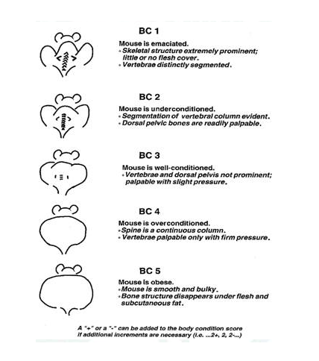

Appendix 3 – Body Condition Scoring (BCS) for Rats

Description of procedure
Scoring the body condition of rodents is a noninvasive method for assessing health and establishing endpoints for adults where body weight is not a viable monitoring tool, such as with tumor models, ascites production and pregnancy, or young growing animals. Body condition scores (BCS) range from 1 (emaciation) to 5 (obesity). An anticipated BCS of 2 (underconditioned) or lower requires justification in the protocol. Scores are determined by frequent visual and hands-on examination of each animal. For the hands-on evaluation, allow the rat to rest on the cage’s wire top. Assess the vertebrae by palpation of the lumbar spine and the pelvic bones by palpation of the hips. Match the findings to the descriptions and diagrams provided to determine a score. Scores must be documented for each animal. Reference used: Hickman, D.L., M. Swan. 2010. Use of a body condition score technique to assess health status in a rat model of polycystic kidney disease. J Am Assoc Lab Anim Sci. 49(2):155-9.

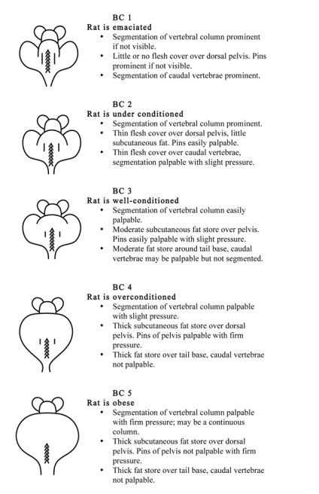
Appendix 4 – Body Condition Scoring (BCS) for Rabbits

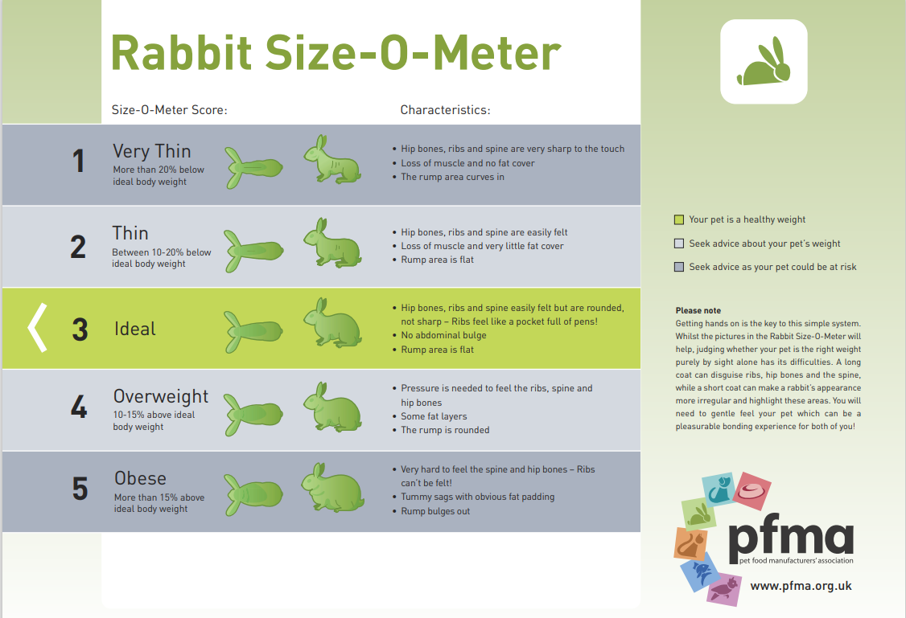

Appendix 5 – Body Condition Scoring (BCS) for Dogs

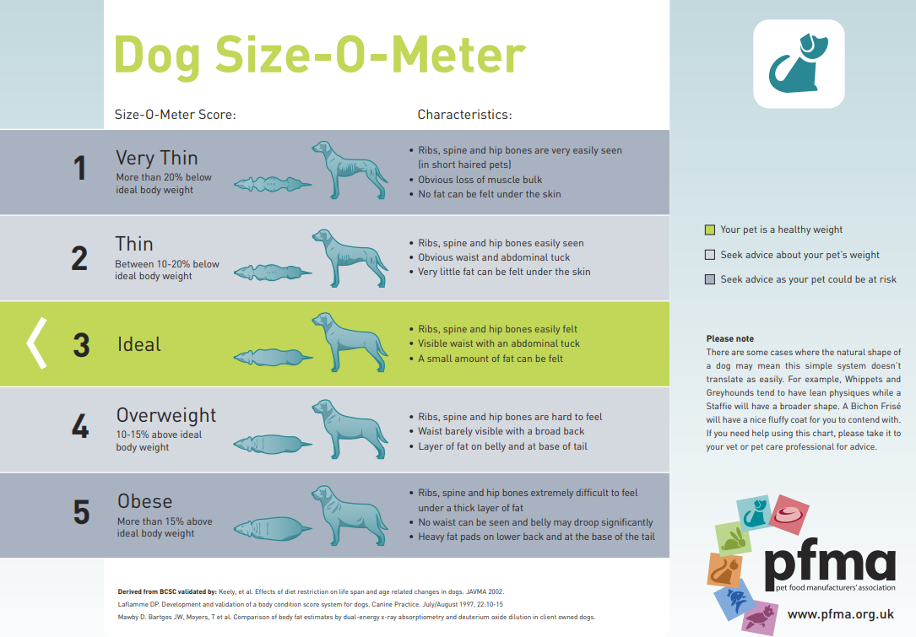

Appendix 6 – Body Condition Scoring (BCS) for Cats

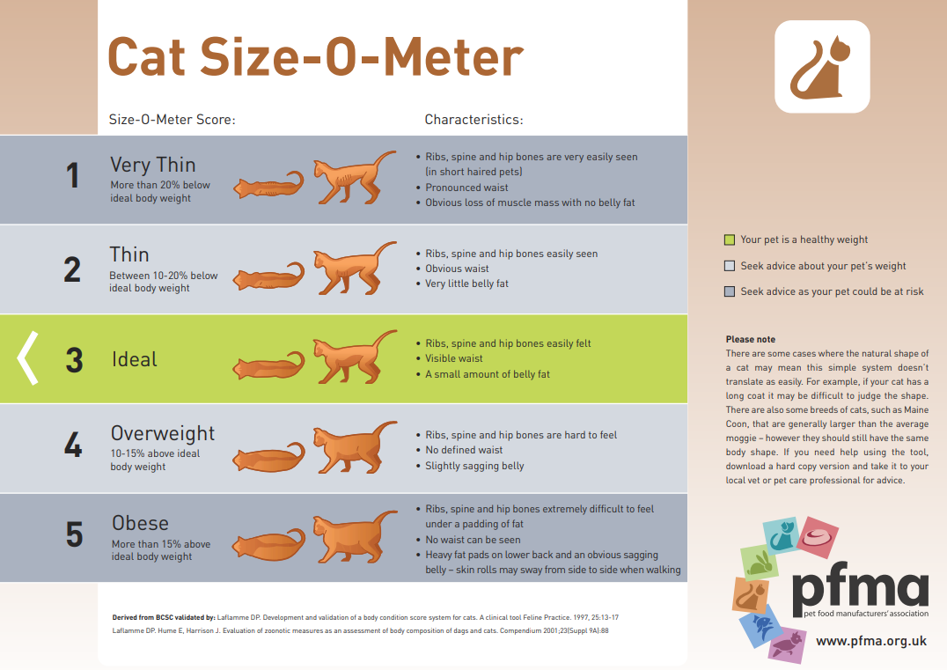

Appendix 7 – Body Condition Scoring (BCS) for Guinea Pigs

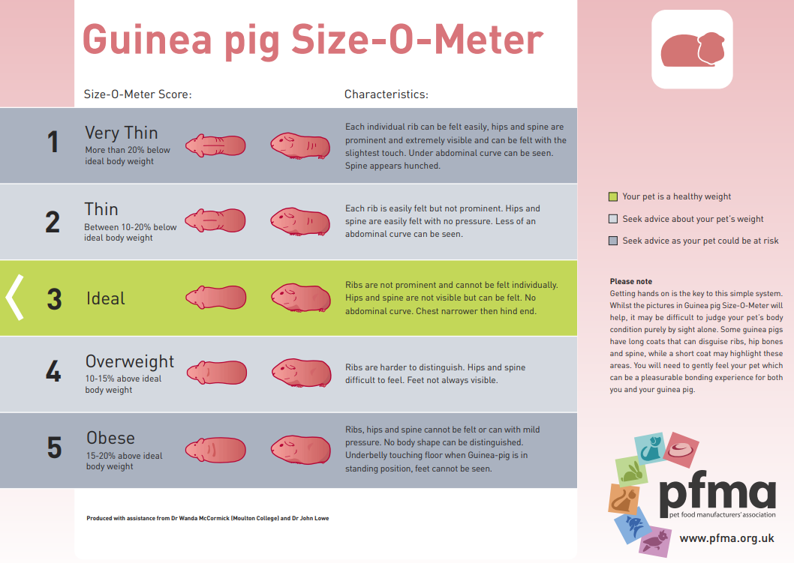

Appendix 8 – Body Condition Scoring (BCS) for Swine

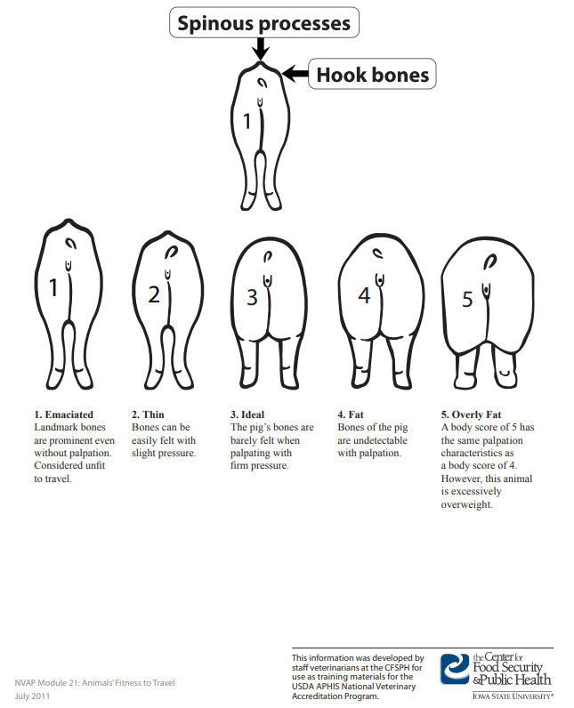

Appendix 9 – Body Condition Scoring (BCS) for Small Ruminants

Sheep

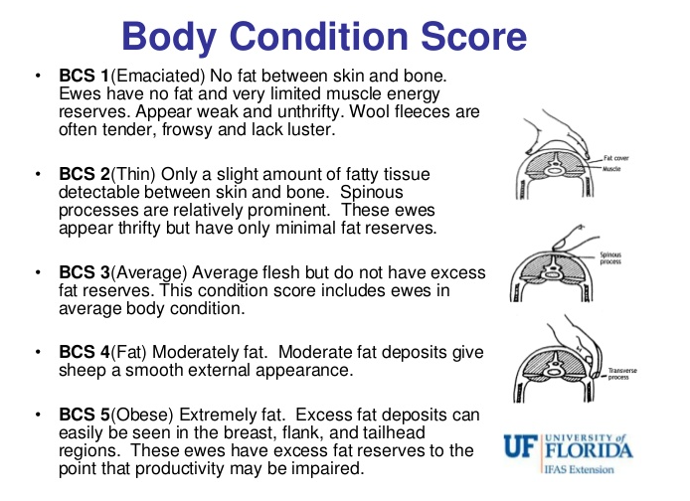

Goats

BCS 1.0 = The goat is visually emaciated and weak. The backbone is highly visible and forms a continuous ridge. The flank is hollow and ribs are clearly visible. There is no fat cover and fingers can easily penetrate into the intercostal spaces.

BCS 2.0 = The goat’s backbone is still visible with a continuous ridge. Some ribs can be seen and there is a small amount of fat cover. Ribs are still felt and intercostal spaces are smooth, but can still be penetrated.

BCS 3.0 = The backbone is not prominent, ribs are barely discernible and an even layer of fat covers the ribs. Intercostal spaces are felt using pressure.

BCS 4.0 = The backbone and ribs cannot be seen. The side of the animal is sleek in appearance.

BCS 5.0 = The backbone is buried in fat and the ribs are not visible. The rib cage is covered with excessive fat.

Appendix 10 – Body Condition Scoring (BCS) for Cattle

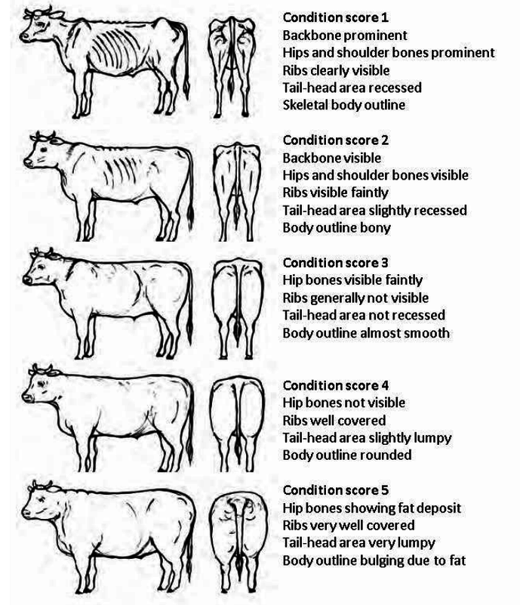

Appendix 11 – Body Condition Scoring (BCS) for Horses

